Join us, virtually, on the 24th of June 2024, Monday, at 6:00 PM CET, for the zoom webinar entitled: “State immunity and immunities of State officials in times of transformation”.
The topic will be presented by Professor Anna Wyrozumska, who is professor of international law and European Union law, University of Lodz, Poland and the President of the Legal Advisory Committee in the Ministry of Foreign Affairs, former member of the Polish delegation at the Rome Conference on the Establishment of an International Criminal Court.
The second speaker will be Professor Magdalena Matusiak-Frącczak, habilitated doctor, attorney, Assistant Professor (University of Lodz, Poland), visiting professor (Chandigarh University, India).

The webinar focuses on various types of exemptions that come from international law from the jurisdiction or enforcement of the state law, i.e. immunities available to states, persons or international organizations. Immunities are available to different entities and have different scope and effects. The institution of immunities, in particular state immunity, finds its justification in the basic principles of the international law system. At the same time, immunities set the framework for mutual relations between states in the exercise of jurisdiction. Contemporary changes, such as strengthening the position of the individual, in particular the protection of his/her fundamental rights, or the increasingly frequent entry of the state into private law relations, make the subject of this study one of the most widely discussed issues in the doctrine of international law. The question therefore arises to what extent immunities must remain inviolable in the interest of maintaining international order and ensuring the efficient functioning of a state in international relations, and to what extent they should be limited, e.g. in the interest of protecting the individual, including the protection of his/her fundamental rights.
The meeting will be moderated by Professor Aleksandra Mężykowska, who is an Associate Professor at the Institute of Legal Studies of the Polish Academy of Sciences, and also a Board Member of the Register of Damage Caused by the Aggression of the Russian Federation against Ukraine and legal expert at the Ministry of Foreign Affairs
The webinar will be conducted in English.
The webinar is a joint event of the Project Sunflowers and the EU Pravo-Justice Project.

Our Speakers:
Professor Anna Wyrozumska  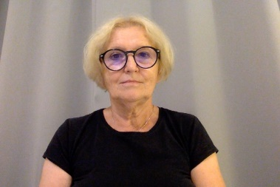 | Prof. Dr. hab. ANNA WYROZUMSKA, Professor emerita of international law and European Union law, University of Lodz, Poland; President of the Legal Advisory Committee in the Ministry of Foreign Affairs; Arbitrator on the national list of the Permanent Court of Arbitration; Conciliator in the OSCE Court of Conciliation and Arbitration. Formerly: head of the department of European Constitutional Law at the Faculty of Law and Administration of the University of Lodz, member of the Polish Legislative Council (2010–2018), counsel and judge ad hoc in the European Court of Human Rights, Director of the Department of Legal and Consular Affairs in the Ministry of Foreign Affairs (2000-2001), member of the Polish delegation at the Rome Conference on the Establishment of an International Criminal Court, member of the Ad Hoc Committee on jurisdictional immunities of States and their property; member of the Polish delegation to the UN General Assembly Sixth Committee.
Professor Magdalena Matusiak-Frącczak   | habilitated doctor, attorney, Assistant Professor (University of Lodz, Poland), visiting professor (Chandigarh University, India)
Professor Aleksandra Mężykowska  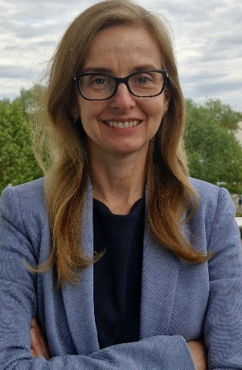 | Aleksandra Mężykowska is an Associate Professor at the Institute of Legal Studies of the Polish Academy of Sciences, Board Member of the Register of Damage Caused by the Aggression of the Russian Federation against Ukraine and legal expert at the Ministry of Foreign Affairs.

